**HTM (Hierarchical Temporal Memory) Classifiers:** It is inspired by the structure and function of the neocortex in the brain. It is designed to learn patterns, make predictions, and recognize anomalies in data set. It is based on Unsupervised Learning.

Encoders, Spatial Pooler, Temporal Memory and Anomaly detection and Prediction are major component of HTM

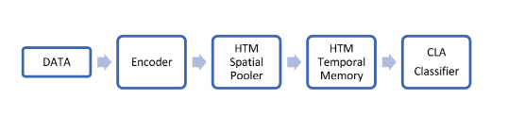

Figure 2: Components of HTM